What is GARCH?

Generalised AutoRegressive Conditional Heteroskedasticity
It’s a statistical model used to estimate and predict volatility that changes over time

GARCH(p,q):
- P = number of lagged variance terms (past volatility)
- Q = Number of lagged squared residuals (past shocks/errors)
- GARCH(1,1): 1 past variance term, 1 past squared error term. The most common version – simple & effective. Volatility today depends on yesterday's volatility and yesterday's shock. Captures volatility clustering (big moves tend to follow big moves)
- GARCH(2,1): More complex, more parameters, higher risk of overfitting (learns the training data too well so performs poorly on new, unseen data). Greater flexibility. More data needed. Harder to estimate. This is why higher order GARCH isn’t preferred

VaR: Value at risk = Expected worst loss over a time period
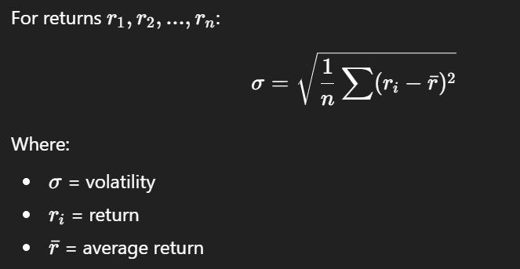
Volatility: How “wild”/unstable price changes are

- Realised volatility: Calculates actual volatility from the past 30 days
- GARCH volatility: Estimates volatility predicted by the model

- Conditional volatility: Conditional on what we already know. Forward looking (a forecast). Depends on past volatility/past shocks (returns)
- Realised/Realized volatility: The volatility actually observed in the data, calculated from real returns. Uses squared returns or high frequency data. Rolling window (1-30, 2-31, rolls) 30 days is common to calc RV
- Difference: CV = model estimate, forward looking, past info + model, forecasting, RV = Actual measurement, backward looking, observed data, evaluation. To put it simply; CV = whether forecast, RV = what the weather was actually like. A good model should produce CV that’s close to RV

The MSE (mean squared error) is calculated by taking the difference between the GARCH volatility and the realized volatility, squaring that difference, and then taking the mean of those squared differences. A lower MSE indicates a better fit of the GARCH model to the realized volatility.
Squarred returns takes in returns to measure volatility. MSE is an error metric that takes in actual & predicted values to measure model accuracy (forecast evaluation)

In many real-world datasets
- Volatility is not consistent
- Big moves tend to be followed by more big moves
- Quiet periods tend to stay quiet
- This is called volatility clustering

The GARCH(1,1) formula is the most common version:
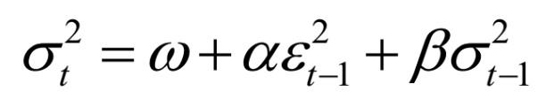
- W (omega) = Baseline volatility level (Long run average volatility
- a (alpha) = Impact of recent shocks. If yesterday had a big move -> volatility increases. Coefficient for lagged squared returns
- b (beta) = Persistence of volatility. If volatility was high yesterday -> it tends to remain high. Coefficient of lagged volatility

Types of GARCH:
- EGARCH (handles asymmetry)
- GJR-GARCH (bad news affects volatility more)
- Multivariate GARCH (multiple assets)

My GARCH(1,1) Model output:
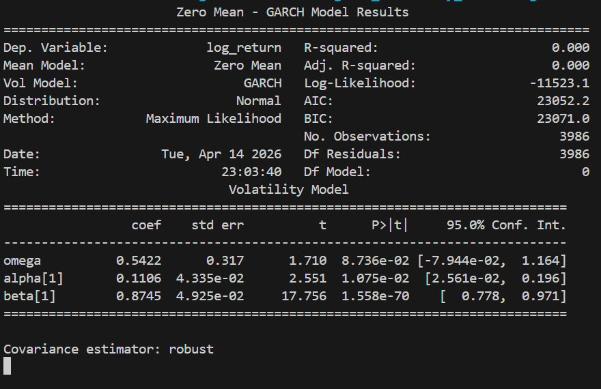
- Dep. Variable: log_return = What was modelled (log returns (not prices), standard)
- Mean Model: Zero mean = Models assumes average return = 0, doesn’t try to predict returns, only volatility
- Vol Model: GARCH = volatility depends on past shocks (returns^2) & past volatility
- Distribution: Normal = Assumed returns are conditionally normally distributed. (Common assumption, but financial returns often have “fat tails”)
- Log-likelihood = measures how well model fits data. Less negative = better
- AIC (Akaike Information Criterion)/BIC (Bayesian Information Criterion) = Penalise complexity. Lower value = better. AIC lighter penalty and prefers complex models, BIC opposite. Both measure how good a model fits the fata whilst penalising complexity
- Df residuals = degrees of freedom. When parameters are estimated some data’s used up some freedom in the data. Like a jigsaw, build the edges first, what’s left for the middle pieces are the DFR
- Conf. Int. = Confidence interval (CI), gives a range of plausible values. 95% = 95% of repeated values fall within this range
- Covariance estimator: robust = Software is using robust standard errors, designed to still be valid even if some model assumptions are wrong. Makes t-stats and p-values more reliable
  - T-stat. big value: Strong evidence the effect is real, low = just noise. T = estimate/standard error
  - P-value: Small = unlikely to be random, significant. Less than 0.05 = significant

Next steps:
Stochastic volatility, Monte Carlo

